**Area**

1.   **Area of a rectangle** = (Length x Breadth).

|  |  |  |  |  |  |  |  |  |
| --- | --- | --- | --- | --- | --- | --- | --- | --- |
| * Length = | http://www.indiabix.com/_files/images/aptitude/1-sym-oparen-h1.gif | Area | http://www.indiabix.com/_files/images/aptitude/1-sym-cparen-h1.gif | and Breadth = | http://www.indiabix.com/_files/images/aptitude/1-sym-oparen-h1.gif | Area | http://www.indiabix.com/_files/images/aptitude/1-sym-cparen-h1.gif | . |
| Breadth | Length |

* + Perimeter of a rectangle = 2(Length + Breadth).

2. **Area of a square** = (side)2 =  (diagonal)2.

3. **Area of 4 walls of a room** = 2 (Length + Breadth) x Height.

4.   **Area of a triangle**

* Area of a triangle = $\frac{1}{2}$  x Base x Height.
* Area of a triangle = *s*(*s*-*a*)(*s*-*b*)(*s*-*c*)

Where *a*, *b*, *c* are the sides of the triangle and *s* = $\frac{1}{2}$ x (*a* + *b* + *c*).

|  |  |  |
| --- | --- | --- |
| * Area of an equilateral triangle = | $$\sqrt{3}$$ | x (side)2. |
| 4 |

|  |  |  |
| --- | --- | --- |
| * Radius of incircle (Inradius) of an equilateral triangle of side *a* = |  | . |
|  |

|  |  |  |
| --- | --- | --- |
| * Radius of circumcircle (Circumradius) of an equilateral triangle of side *a* = $\frac{a}{\sqrt{3}}$* Area of Triangle = r X s, where r = inradius and s = semiperimeter * Area of Triangle = $\frac{abc}{4R}$, where R = Circumradius. * In case of triangles, given the perimeter and equilateral triangle has maximum area. * Area of right-angled triangle = $\frac{1}{2}$ X Product of perpendicular sides. * The ratio of the areas of 2 triangles is equal to the ratio of the product of base and its corresponding height. $\frac{A (∆ABC)}{A (∆PQR)}$  = $\frac{AD X BC}{PS X QR}$  * Areas of 2 triangles having the same base and lying between the same parallel lines will be equal.   A ( |  |  |
|  |

5. **Area of Polygon = $\frac{1}{2}$**  X perimeter X perpendicular from centre to any side

* + Area of regular hexagon = 6 X Area of each triangle

= 6 X $\frac{\sqrt{3}}{4}$ X =

* + Area of Quadrilateral = $\frac{1}{2}$ X One of the diagonals X sum of the perpendicular drawn to that diagonal from the opposite vertices.
  + Area of parallelogram = (Base x Height).
  + Area of a rhombus = $\frac{1}{2}$  x (Product of diagonals)
  + Area of a trapezium = $\frac{1}{2}$  x (sum of parallel sides) x distance between them
  + Area of Kite = $\frac{1}{2}$ X product of diagonals

1. **Area of a circle** = R2, where R is the radius.

* Circumference of a circle = 2 $π$ R.
* Length of an arc = $\frac{2πRθ}{360}$, where $θ$ is the central angle.
* Area of a sector = $\frac{1}{2}\left(arc X R\right)= \frac{πR^{2}θ}{360}$
* Circumference of a semi-circle = $πR$
* Area of semi-circle = $\frac{πR^{2}}{2}$

Volume & Surface Area

1. **CUBOID**

Let length = *l*, breadth = *b* and height = *h* units. Then

**Volume** = (*l* x *b* x *h*) cubic units.

**Surface area** = 2(*lb* + *bh* + *lh*) sq. units.

**Diagonal** = $\sqrt{l2 + b2 + h2}$  units.

1. **CUBE**

Let each edge of a cube be of length *a*. Then,

**Volume** = *a*3 cubic units.

**Surface area** = 6*a*2 sq. units.

**Diagonal** = $√$ 3*a* units.

1. **CYLINDER**

Let radius of base = *r* and Height (or length) = *h*. Then,

**Volume** = (*r*2*h*) cubic units.

**Curved surface area =** (2 $π$*rh*) sq. units.

**Total surface area** = 2 $π$*r*(*h* + *r*) sq. units.

1. **CONE**

Let radius of base = *r* and Height = *h*. Then,

**Slant height,** *l* = $\sqrt{h2 + r2 }$  units.

**Volume** = $\frac{1}{3}πr^{2}h$ cubic units.

**Curved surface area** = ($π$*rl*) sq. units.

**Total surface area** = (*rl* + *r*2) sq. units.

1. **SPHERE**

Let the radius of the sphere be *r*. Then,

**Volume** = $\frac{4}{3}πr^{3}$  cubic units.

**Surface area** = (4*r*2) sq. units.

1. **HEMISPHERE**

Let the radius of a hemisphere be *r*. Then,

**Volume** = $\frac{2}{3}πr^{3}$ cubic units.

**Curved surface area** = (2*r*2) sq. units.

**Total surface area** = (3*r*2) sq. units.

Note: 1 litre = 1000 cm3.

**Polygon & Quadrilaterals**

**Polygons**

Polygons are many-sided figures, with sides that are line segments. Polygons are named according to the number of sides and angles they have.

|  |  |  |  |
| --- | --- | --- | --- |
| **Polygon** | **No. of Sides** | **No. of Angles** | **No. of diagonals** |
| **Triangle** | **3** | **3** | **0** |
| **Quadrilateral** | **4** | **4** | **2** |
| **Pentagon** | **5** | **5** | **5** |
| **Hexagon** | **6** | **6** | **9** |
| **Heptagon** | **7** | **7** | **14** |
| **Octagon** | **8** | **8** | **20** |
| **Nonagon** | **9** | **9** | **27** |
| **Decagon** | **10** | **10** | **35** |

**Properties of Polygon:**

* A polygon with equal sides is called “Regular Polygon”.
* The segment joining any two non-consecutive vertices is called a diagonal.

Number of diagonals of a polygon with n sides = $\frac{n (n-3)}{2}$

For ex. In a Octagon number of diagonals will be $\frac{8 (8-3)}{2}$ = 20

* Sum of all interior angles of a n-gon (polygon of n sides n) is given by (n-2)180°

Hence, each interior angle of a regular n-gon = $\frac{ (n-2)180°}{n}$

* Sum of an interior angle and its adjacent exterior angle is 180°.
* Sum of all exterior angles of polygon is 360°
* For a regular polygon, each exterior angle = $\frac{360°}{n}$
* In a regular Pentagon each interior angle is 108**°** and each exterior angle is 72°.
* In a regular Pentagon each interior angle is 120**°** and each exterior angle is 60°.

**Quadrilaterals**

A polygon of four sides is called quadrilateral. The sum of measures of all angles of a quadrilateral is 360°.

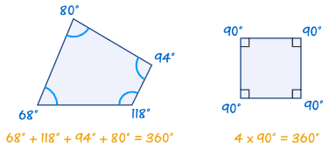

**Types of Quadrilaterals**

1. **Parallelogram: A quadrilateral is called parallelogram, if its opposite sides are parallel.**

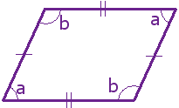

* Opposite sides are parallel and congruent.
* **Opposite angles are congruent.**
* **Diagonals bisect each other.**
* **Sum of any two adjacent angles is 180**°.
* **Each diagonal divides the parallelogram into 2 triangles of equal area.**
* **Straight lines joining the midpoints of the adjacent sides of any quadrilateral from a parallelogram.**
* **Sum of the squares of the diagonals is equal to the sum of squares of the 4 sides of a parallelogram.**

$AC^{2}+ BD^{2} = AB^{2}+ BC^{2}+ CD^{2}+ AD^{2}=2(AB^{2}+ AC^{2})$

* **Parallelograms that lie on the same base and between the same parallel lines are equal in area.**
* **If a triangle and parallelogram lie on the same base and between the same parallel lines, Area (triangle) = $\frac{1}{2}$ Area (Parallelogram)**
* **If midpoints of the adjacent sides of a parallelogram are joined, a parallelogram is formed.**

1. **Rectangle: A parallelogram, in which each angle is a right angle is called rectangle.**

|  |
| --- |
| Rectangle |
|

* **Opposite sides are parallel and congruent.**
* **Each angle is equal to 90**°
* **Diagonal are congruent and bisect each other.**
* **If midpoints of the adjacent sides of a rectangle are joined, a rhombus is formed.**

1. **Rhombus: A parallelogram in which all sides are congruent is called Rhombus.**

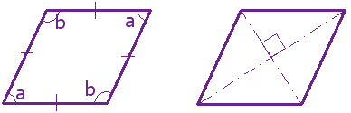

* **Opposite sides are parallel.**
* **All sides are congruent.**
* **Opposite angles are congruent.**
* **Diagonals bisect at right angles**
$side^{2}={\left(\frac{1}{2} one diagonal\right)}^{2}+ {\left(\frac{1}{2} other diagonal\right)}^{2}$

* **A parallelogram is a rhombus if its diagonals are perpendicular to each other.**
* **If midpoints of the adjacent sides of a rhombus are joined, a rectangle is formed.**

1. **Square: A rectangle in which all sides are congruent is called a squire.**

|  |  |  |
| --- | --- | --- |
| Square |  |  |
|  |  |

* **All sides are congruent and opposite sides are parallel.**
* **All angles are 90**°.
* **The diagonals are congruent and bisect each other at right angles.**
* **Diagonal = $√2$ X side**
* **A parallelogram is a square if its diagonals are congruent and bisect each other at right angles.**
* **If midpoints of the adjacent sides of a square are joined, a square is formed.**

1. **Trapezium: A quadrilateral is called a trapezium, if two of the opposite sides are parallel but the other sides are not.**

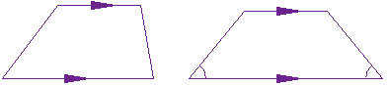

* The segment joining the midpoints of the oblique (non parallel) sides is called median of the trapezium.

Median = $\frac{1}{2}$ **X sum of parallel sides**

1. Kite: A quadrilateral is called a kite, if it has two pairs of equal and adjacent sides.

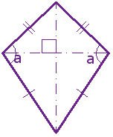

* Two pairs of adjacent sides are congruent.
* The diagonals intersect at right angles.
* The longer diagonal bisects the shorter one.

**Co- Ordinate Geometry**

Co-ordinate Geometry is that branch of geometry in which 2 numbers i.e. the co-ordinates are used to indicate the position of a point in the plane.

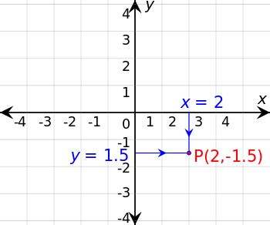

The horizontal line is called the “X axis” and the vertical line is called “Y axis”. Their point of interaction is called the “Origin”. The x and y axis divide the plane into 4 quadrants referred as first, second, third and fourth quadrant.

If P be a point in fourth quadrant, its distance from X and Y axis is called rectangular Cartesian or “Co-ordinates of P”. The x and y co-ordinates of a point in the quadrant are:

|  |  |  |  |
| --- | --- | --- | --- |
| Quadrant | x - co-ordinate | y – coordinate | Coordinates |
| First | + | + | (+,+) |
| Second | - | + | (-,+) |
| Third | - | - | (-,-) |
| Fourth | + | - | (+,-) |

**Important Points**

1. **Distance formula:**

The distance between two points (x1, y1) and (x2, y2) = $\sqrt{{\left(x1-x2\right)}^{2}+{\left(y1-y2\right)}^{2}}$

1. **Section Formula:**

**Internal Division:** If P is a point dividing the joint of two points A(x1, y1) and B(x2, y2) internally in the ratio m: n then co-ordinates (x, y) of P is given by:

P(x,y) = $(\frac{mx2+nx1}{m+n}, \frac{my2+ny1}{m+n})$

**External Division:** If P is a point dividing the joint of two points A(x1, y1) and B(x2, y2) externally in the ratio m: n then co-ordinates (x, y) of P is given by:

P(x,y) = $(\frac{mx2-nx1}{m-n}, \frac{my2-ny1}{m-n})$

**Midpoint:** If P is the midpoint of segment then: P(x,y) = $(\frac{x1+x2}{2}, \frac{y1+y2}{2})$

1. **Centroid of a Triangle:** Centroid is the point of intersection of 3 medians of triangle

If A(x1, y1), B(x2, y2) and C(x3, y3) are the vertices of a triangle, then The co-ordinates of the centroid G(x,y) of the the $∆$ ABC are:

G(x,y) = ($\frac{x1+x2+x3}{3}, \frac{y1+y2+y3}{3})$

1. **Incentre of a Triangle:** Incentre is the point of intersection of three angle bisector of triangle.

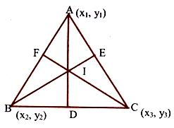

The co-ordinates of the incentre (x, y) of the $∆$ ABC with vertices A(x1, y1), B(x2, y2) and C(x3, y3) are

I(x, y) = ($\frac{ax1+bx2+cx3}{a+b+c}, \frac{ay1+by2+cy3}{a+b+c})$

1. **Area of Triangle:**

If A(x1, y1), B(x2, y2) and C(x3, y3) are 3 vertices of triangle then:

Area of triangle = $\frac{1}{2}$ [x1(y2 – y3) – x2(y1 – y3) – x3(y1 – y3)]

If the area = 0, then 3 points are collinear.

**Equation of a line**

A geometrical condition satisfied by all points P(x,y) on a straight line when expressed in x or y is called equation of a straight line.

**Inclination of a line**

If a straight line intersects the x-axis, the inclination of the line is defined as the measure of the angle. The slope of a line is the ratio of rate of change of y to rate of change of x. It is defined by ‘m’. Slope of a line joining 2 points A(x1, y1), B(x2, y2)

m = $\frac{y2-y1}{x2-x1}$ = $\tan{θ}$

Two lines whose slopes m1 and m2 are parallel to each other than m1 = m2;

Two lines whose slopes are m1 and m2 are parallel to each other, if and only if m1 X m2 = -1

Thus, if the slope of a line is m, the slope of a line perpendicular to it is - $\frac{1}{m}$

**Important Points**

* The equation of a line parallel to x axis and at a distance of k units is y = k.
* Equation of x axis is y = 0
* The equation of a line parallel to y axis at a distance of k units below it is y = -k
* Equation of y axis is x = 0
* The equation of a straight line passing through the point (x1, y1) and having slope m is

y – y1 = m(x – x1)

* The equation of a straight line passing through the points (x1, y1) and (x2, y2)

$\frac{y-y1}{x-x1}= \frac{y1-y2}{x1-x2}$**,** where x1 $≠$ x2

* The equation of a line having slope m and making an intercept c on y – axis is y = mx + c
* The equation of a line making intercepts a and b, when a ≠ 0 and b ≠ 0 $\frac{x}{a}+ \frac{y}{b}=1$
* If the perpendicular drawn from the origin to a line has inclination α and length p, then the equation of the line is x $\cos{α}+ \operatorname{ysin}{α}=p$
* The equation of a line passing through a point (x 1, y1) and making an angle of $θ$ with x axis is $\frac{x-x1}{\cos{θ}}= \frac{y-y1}{\sin{θ}}$
* The most general form of an equation is of the form Ax + By + C = 0, always represent a line Slope m = $-\frac{A}{B}= \frac{- Cofficient of x}{Coefficient of y}$,

x intercept = $-\frac{C}{A}= - \frac{ Constant term}{Coefficient of x}$, y intercept = $-\frac{C}{B}= - \frac{ Constant term}{Coefficient of y}$

* If m1 and m2 are the slopes of 2 lines such that m1 X m2 ≠ 1, then tan $θ= \frac{m1-m2}{1 +m1m2}$

The perpendicular distance

**Perpendicular Distance**

* The perpendicular distance of origin from a line Ax + By + C = 0, is given by $\frac{C}{\sqrt{A^{2}+B^{2}}}$
* If P(x1 , y1) is any point and Ax + By + C = 0 is a line, then the perpendicular distance of p from line is $\frac{Ax1+By1+ C}{\sqrt{A^{2}+B^{2}}}$
* Distance between 2 parallel lines Ax + By + C1 = 0 and Ax + By + C2 = 0 is $\frac{ C1-C2}{\sqrt{A^{2}+B^{2}}}$

**Equation of Circle and Ellipse**

* **Equation of a circle:** If P(x, y) be any point on the circle whose center is C(h, k) and radius is r. The equation of circle is given by $\sqrt{{\left(x-h\right)}^{2}+{\left(y-k\right)}^{2}}$ = r.

When center is origin then equation is $\sqrt{x^{2}+y^{2}}=r$

The general form a circle with center as origin is $x^{2}+y^{2}+2gx+2fy+c=0$.

* **Equation of Ellipse:** An ellipse is the locus of a point, which moves such that the ratio ‘e’ of its distance from a fixed point and a fixed straight line is a constant and e $≤1$

The equation of an ellipse in the standard form is $\frac{x^{2}}{a^{2}}+ \frac{y^{2}}{b^{2}}$ = 1, where a and b are the lengths of the major and minor axis of ellipse.

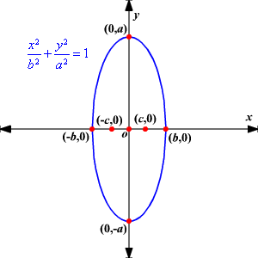

Area of ellipse = π (ab)

Perimeter = π (a + b)

If a = b ellipse is circle.

**Triangles**

The plane figure bounded by the union of 3 lines, which join 3 non – collinear points, is called a triangle. It is denoted by symbol $∆$.

**Properties of Triangle**:

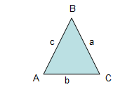

1. The sum of interior angles of a triangle is 180 $°$.
2. The sum of an interior angle and the adjacent exterior angle is 180 $°$.
3. Two exterior angles having same vertex are congruent.
4. The sum of lengths of any 2 sides of a triangle is always greater than the third side. In $∆$ ABC a + b > c ; b + c > a ; a + c > b
5. The difference of any 2 sides is always less than the 3rd side.

In $∆$ ABC a – b < c; b – c < a; a – c < b

1. A triangle will have at least 2 acute angles.

**Types of Triangles:**

With regard to their sides, triangles are of 3 types

|  |  |
| --- | --- |
| Equilateral Triangle | **Equilateral Triangle**  Three equal sides  Three equal angles, always 60° |
| Isosceles Triangle | **Isosceles Triangle**  Two equal sides  Two equal angles |
| Scalene Triangle | **Scalene Triangle**  No equal sides  No equal angles |

With regard to angles, triangles are of three types:

|  |  |
| --- | --- |
| Acute Triangle | **Acute Triangle**  All angles are less than 90° |
| Right Triangle | **Right Triangle**  Has a right angle (90°) |
| Obtuse Triangle | **Obtuse Triangle**  Has an angle more than 90° |

**Similarity of Triangles**

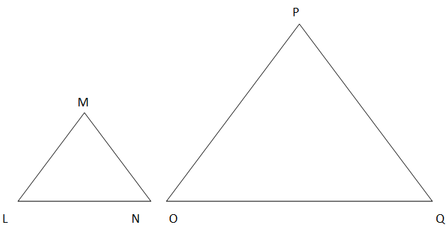

### When Are Triangles Similar?

Two triangles are similar if any one of the following three possible scenarios is met:

1. AAA [Angle Angle Angle] - The corresponding angles of each triangle have the same measurement.  
   In other words, the above triangles are similar if:  
   Angle L = Angle O; Angle N = Angle Q; Angle M = Angle P
2. SAS [Side Angle Side] - An angle in one triangle is the same measurement as an angle in the other triangle and the two sides containing these angles have the same ratio.  
   In other words, the above triangles are similar if:  
   Angle L = Angle O; Side LM/Side OP = Side LN/Side OQ  
   Note: Any other combination of side, angle, side also proves similarity.
3. SSS [Side Side Side] - Each pair of corresponding sides have the same ratio.  
   In other words, the above triangles are similar if:  
   Side LM/Side OP = Side LN/Side OQ = Side MN/Side PQ

### Properties of Similar Triangles

1. Corresponding angles are the same measurement.
2. The perimeter of each triangle is in the same ratio as the sides.
3. Corresponding sides are all in the same proportion.
4. The triangles on each side of the altitude drawn from the vertex of the right angle to the hypotenuse are similar to the original triangle and to each other.

## Congruency of Triangles

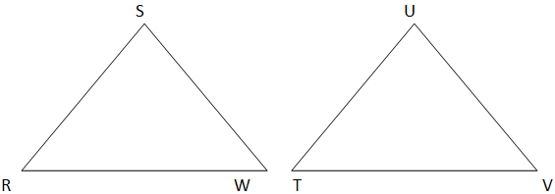

### When Are Triangles Congruent?

Two triangles are congruent if any one of the following three possible scenarios is met:

1. SAS [Side Angle Side] - Two pairs of corresponding sides are equal and the corresponding angle between the sides is equal.  
   In other words, the above triangles are congruent if:  
   Side SW = Side UV; Angle W = Angle V; Side WR = Side VT  
   Note: Any other combination of side, angle, side also proves congruence.
2. ASA [Angle Side Angle] - Two pairs of corresponding angles are equal and the corresponding side between them is equal.  
   In other words, the above triangles are congruent if:  
   Angle R = Angle T; Side RW = Side TV; Angle W = Angle V  
   Note: Any other combination of angle, side, angle also proves congruence.
3. SSS [Side Side Side] - All three pairs of corresponding sides are equal.  
   In other words, the above triangles are congruent if:  
   Side RS = Side TU; = Side RW = Side TV; Side SW = Side UV

### Properties of Congruent Triangles

1. Corresponding angles have the same measurement.
2. Corresponding sides have the same measurement.

**Triangle Based Theorems:**

* **Pythagoras Theorem:** In a right-angled triangle, the square of the hypotenuse is equal to the sum of the squares of the other 2 sides.

$AC^{2}=AB^{2}+BC^{2}$

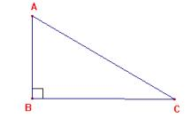

In an “Obtuse angle triangle”, $AB^{2}+BC^{2}<AC^{2}$

In an “Acute angle triangle”, $AB^{2}+BC^{2}<AC^{2}$

* **Midpoint Theorem:** The segment joining the midpoints of any 2 sides of triangle is parallel to the third side and is half of the third side.

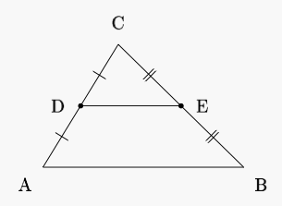

If AD = DB, AE = EC, then DE is parallel to BC and DE = $\frac{1}{2}$ BC

* **Basic Proportionality Theorem:** If a line is drawn parallel to one side of a triangle and intersects other sides in 2 distinct points, then the other sides are divided in the same ratio by it.

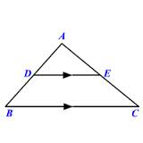

If DE is parallel to BC, then $\frac{AD}{DB}= \frac{AE}{EC}$

* **Interior Angle Bisector Theorem:** The angle bisector of any angle of a triangle divides the side opposite to the angle in the ratio of the remaining two sides.

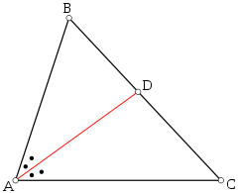

In $∆$ ABC, if AD is the angle bisector of $∠$ BAC, then, $\frac{AB}{AC}= \frac{BC}{CD}$

* **Exterior Angle Bisector Theorem:** The angle bisector of any exterior angle of a triangle divides the side opposite to the angle (externally) in the ratio of the remaining two sides.

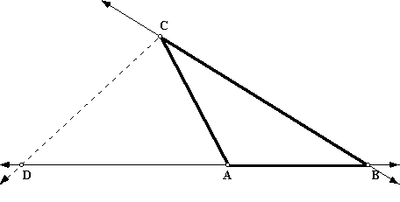

In $∆$ ABC, ­­­­­­­CD is the exterior angle bisector, Here, $\frac{CA}{CB}= \frac{BD}{CD}$

* **Appollonius Theorem:** The sum of squares of any two sides of a triangle is equal to twice the sum of the square of the median to the third side and square of half the third side:

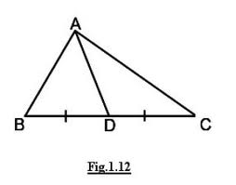

**AD is the median of $∆$**  ABC. $AB^{2}+AC^{2}=2(AD^{2}+DC^{2})$

Here we will assume that you are familiar with angles and how they are measured, in particular with *radians*. If you are not sure, you can have a look at [this note](http://math.feld.cvut.cz/mt/txtb/4/txe4ba4c.htm).

There are several ways to define trigonometric functions. We will briefly recall two of them, based on geometric ideas. Then we will look at [properties](http://math.feld.cvut.cz/mt/txtb/4/txe3ba4e.htm#1) of trigonometric functions, recall some [trig identities](http://math.feld.cvut.cz/mt/txtb/4/txe3ba4e.htm#2), try to make some sense of their [inverses](http://math.feld.cvut.cz/mt/txtb/4/txe3ba4e.htm#3) and conclude with a brief note concerning [secant](http://math.feld.cvut.cz/mt/txtb/4/txe3ba4e.htm#4) and cosecant.

## Geometric definitions

**Unit cirlce.** Let http://math.feld.cvut.cz/mt/pics/piccal.gif be any angle. Consider a unit circle in the plain and the ray going from the origin at the angle http://math.feld.cvut.cz/mt/pics/piccal.gif. Let (*x*,*y*) be the coordinates of the intersection of the ray and the unit circle. We then define

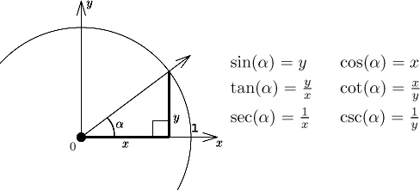

Of course, some definitions do not make sense if *x* = 0, resp. *y* = 0.

Clearly we then have

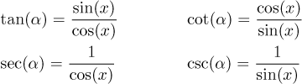

The functions sec(http://math.feld.cvut.cz/mt/pics/piccal.gif) (secant) and csc(http://math.feld.cvut.cz/mt/pics/piccal.gif) (cosecant) used to be very popular in the old days when people still had to calculate things by themselves, since they simplified calculations with trig functions. Today they are mostly forgotten and we include them here for the sake of completeness. We will return to them at the end of this section.

Note that when defined like this, all these functions are 2http://math.feld.cvut.cz/mt/pics/piccpi.gif-periodic, under closer inspection tangent and cotangent are http://math.feld.cvut.cz/mt/pics/piccpi.gif-periodic.

**Right-angle triangle.** Let http://math.feld.cvut.cz/mt/pics/piccal.gif be an angle from the interval (0,http://math.feld.cvut.cz/mt/pics/piccpi.gif/2). Consider an arbitrary right-angle triangle with another angle equal to http://math.feld.cvut.cz/mt/pics/piccal.gif. We then have the folowing definitions:

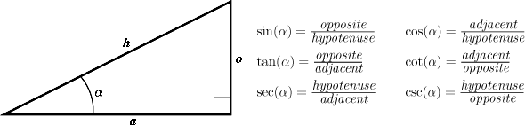

These functions are connected by the same formulas as above. How do we extend these definitions to any angle http://math.feld.cvut.cz/mt/pics/piccal.gif? First we define sin(0) = 0, cos(0) = 1, sin(http://math.feld.cvut.cz/mt/pics/piccpi.gif/2) = 1, cos(http://math.feld.cvut.cz/mt/pics/piccpi.gif/2) = 0.

For http://math.feld.cvut.cz/mt/pics/piccal.gif from [http://math.feld.cvut.cz/mt/pics/piccpi.gif/2,http://math.feld.cvut.cz/mt/pics/piccpi.gif] we define sin(http://math.feld.cvut.cz/mt/pics/piccal.gif) = sin(http://math.feld.cvut.cz/mt/pics/piccpi.gif - http://math.feld.cvut.cz/mt/pics/piccal.gif) and cos(http://math.feld.cvut.cz/mt/pics/piccal.gif) = -cos(http://math.feld.cvut.cz/mt/pics/piccpi.gif - http://math.feld.cvut.cz/mt/pics/piccal.gif).

For http://math.feld.cvut.cz/mt/pics/piccal.gif from [http://math.feld.cvut.cz/mt/pics/piccpi.gif,2http://math.feld.cvut.cz/mt/pics/piccpi.gif] we define sin(http://math.feld.cvut.cz/mt/pics/piccal.gif) = -sin(http://math.feld.cvut.cz/mt/pics/piccal.gif - http://math.feld.cvut.cz/mt/pics/piccpi.gif) and cos(http://math.feld.cvut.cz/mt/pics/piccal.gif) = -cos(2http://math.feld.cvut.cz/mt/pics/piccpi.gif - http://math.feld.cvut.cz/mt/pics/piccal.gif).

Thus we get sine and cosine on [0,2http://math.feld.cvut.cz/mt/pics/piccpi.gif], then we extend them to all angles by repeating this basic period. The other functions can be all defined using sine and cosine and the above formulas.

We conclude this part by recalling the values of sine and cosine for the popular angles:

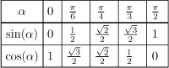

There is a [simple way to remember](http://math.feld.cvut.cz/mt/txtb/4/txe4ba4d.htm) these using the left hand.

Another practical remark, instead of writing [sin(*x*)]*n* we usually write sin*n*(*x*), similarly for other trig functions.

## Properties of trigonometric functions

**The sine.** The domain:

*D*(sin) = http://math.feld.cvut.cz/mt/pics/piccr.gif.

The graph:

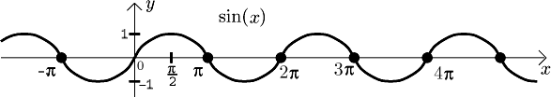

The function is continuous on its domain, 2http://math.feld.cvut.cz/mt/pics/piccpi.gif-periodic, bounded, and symmetric, namely odd, since we have sin(-*x*) = -sin(*x*). We also have

sin(*x* + http://math.feld.cvut.cz/mt/pics/piccpi.gif) = -sin(*x*),       sin(*x* + http://math.feld.cvut.cz/mt/pics/piccpi.gif/2) = cos(*x*),       sin(*x* - http://math.feld.cvut.cz/mt/pics/piccpi.gif/2) = -cos(*x*).

From the periodicity we have

sin(*x* + 2*k*http://math.feld.cvut.cz/mt/pics/piccpi.gif) = sin(*x*),       sin(*x* + (2*k* + 1)http://math.feld.cvut.cz/mt/pics/piccpi.gif) = -sin(*x*).

Zero points of sine are points of the form *k*http://math.feld.cvut.cz/mt/pics/piccpi.gif, where *k* is any integer; these are also points of inflection. Local extrema are at the points http://math.feld.cvut.cz/mt/pics/piccpi.gif/2 + *k*http://math.feld.cvut.cz/mt/pics/piccpi.gif.

Concerning limits at endpoints of the domain, limits of sine at infinity and negative infinity do not exist.

The derivative:

[sin(*x*)]' = cos(*x*).

**The cosine.** The domain:

*D*(cos) = http://math.feld.cvut.cz/mt/pics/piccr.gif.

The graph:

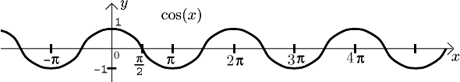

The function is continuous on its domain, 2http://math.feld.cvut.cz/mt/pics/piccpi.gif-periodic, bounded, and symmetric, namely even, since we have cos(-*x*) = cos(*x*). We also have

cos(*x* + http://math.feld.cvut.cz/mt/pics/piccpi.gif) = -cos(*x*),       cos(*x* + http://math.feld.cvut.cz/mt/pics/piccpi.gif/2) = -sin(*x*),       cos(*x* - http://math.feld.cvut.cz/mt/pics/piccpi.gif/2) = sin(*x*).

From the periodicity we have

cos(*x* + 2*k*http://math.feld.cvut.cz/mt/pics/piccpi.gif) = cos(*x*),       cos(*x* + (2*k* + 1)http://math.feld.cvut.cz/mt/pics/piccpi.gif) = -cos(*x*).

Zero points of cosine are points of the form http://math.feld.cvut.cz/mt/pics/piccpi.gif/2 + *k*http://math.feld.cvut.cz/mt/pics/piccpi.gif, where *k* is any integer; these are also points of inflection. Local extrema are at the points *k*http://math.feld.cvut.cz/mt/pics/piccpi.gif.

Concerning limits at endpoints of the domain, limits of cosine at infinity and negative infinity do not exist.

The derivative:

[cos(*x*)]' = -sin(*x*).

**The tangent.** The domain:

http://math.feld.cvut.cz/mt/txtb/4/gifa4/pe3ba4eg.gif

The graph:

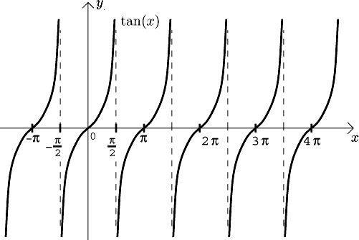

The function is continuous on its domain, http://math.feld.cvut.cz/mt/pics/piccpi.gif-periodic, not bounded, and symmetric, namely odd, since we have tan(-*x*) = -tan(*x*). We also have

tan(*x* + http://math.feld.cvut.cz/mt/pics/piccpi.gif) = tan(*x*),       tan(http://math.feld.cvut.cz/mt/pics/piccpi.gif - *x*) = -tan(*x*).

Zero points of tangent are points of the form *k*http://math.feld.cvut.cz/mt/pics/piccpi.gif, where *k* is any integer; these are also points of inflection. There are no local extrema.

Concerning limits at endpoints of the domain, limits of tangent at infinity and negative infinity do no make sense since the domain does not include any neighborhood of infinity or negative infinity. Limits at finite endpoints of the domain do not exist, but we have one-sided limits there:

http://math.feld.cvut.cz/mt/txtb/4/gifa4/pe3ba4ei.gif

The derivative:

[tan(*x*)]' = 1/cos2(*x*).

**The cotangent.** The domain:

http://math.feld.cvut.cz/mt/txtb/4/gifa4/pe3ba4ej.gif

The graph:

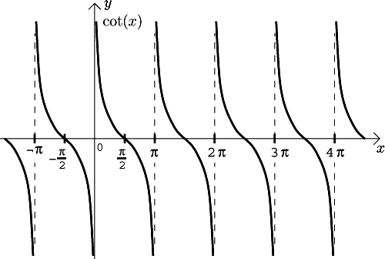

The function is continuous on its domain, http://math.feld.cvut.cz/mt/pics/piccpi.gif-periodic, not bounded, and symmetric, namely odd, since we have cot(-*x*) = -cot(*x*). We also have

cot(*x* + http://math.feld.cvut.cz/mt/pics/piccpi.gif) = cot(*x*),       cot(http://math.feld.cvut.cz/mt/pics/piccpi.gif - *x*) = -cot(*x*).

Zero points of cotangent are points of the form http://math.feld.cvut.cz/mt/pics/piccpi.gif/2 + *k*http://math.feld.cvut.cz/mt/pics/piccpi.gif, where *k* is any integer; these are also points of inflection. There are no local extrema.

Concerning limits at endpoints of the domain, limits of cotangent at infinity and negative infinity do no make sense since the domain does not include any neighborhood of infinity or negative infinity. Limits at finite endpoints of the domain do not exist, but we have one-sided limits there:

http://math.feld.cvut.cz/mt/txtb/4/gifa4/pe3ba4el.gif

The derivative:

[cot(*x*)]' = -1/sin2(*x*).

## Trig identities

First some popular identities for sine and cosine.

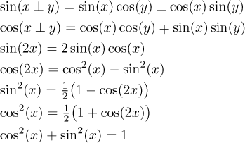

The following identities are less popular, but sometimes they are very useful.

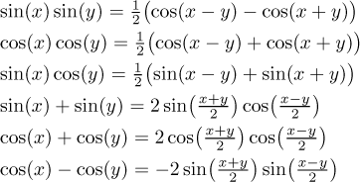

Sine and cosine can be also obtained (or even defined) using exponentials and complex numbers.

http://math.feld.cvut.cz/mt/txtb/4/gifa4/pc3ba4eo.gif

Finally, sometimes this trick is also useful.

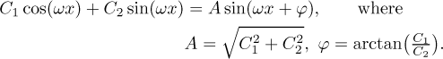

We have an obvious problem when *C*2 = 0. Then we can take  http://math.feld.cvut.cz/mt/pics/piccphi.gif = http://math.feld.cvut.cz/mt/pics/piccpi.gif/2  if  *C*2 > 0  and  http://math.feld.cvut.cz/mt/pics/piccphi.gif = -http://math.feld.cvut.cz/mt/pics/piccpi.gif/2  if  *C*2 < 0.

Now some popular identities for tangent and cotangent.

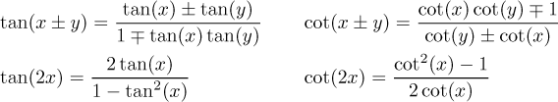

Since sine and cosine can be expressed using complex exponentials, the same is true for tangent and cotangent.

http://math.feld.cvut.cz/mt/txtb/4/gifa4/pe3ba4er.gif

Finally, we will show some formulas that relate sine/cosine and tangent.

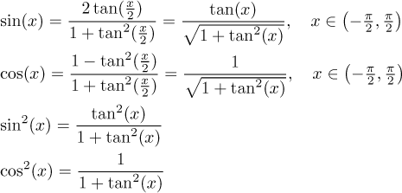

## Inverse trigonometric functions

When we look at the graphs above, we see right away that none of the four basic trig functions is 1-1, so they do not have inverses. On the other hand, from practical point of view, some sort of inverse would be immensely useful, and indeed people were assigning angles to sides of triangles long before mathematicians came up with the notion of inverse. In order to do this properly we use the usual trick, we will restrict the trig functions to intervals on which they are already 1-1. We will choose intervals so that they are as large as possible (so that they cover the whole range) and also so that they give "reasonable" angles, meaning around 0. Indeed, it is more practical to learn that the angle in a triangle is 30 degrees then learning that it is 750 degrees (we should be actually using radians, but degrees are easier to imagine and type on the Web, so I made an exception here).

**Inverse trigonometric functions.** They are defined as follows. First we restrict the four trigonometric functions to intervals as indicated.

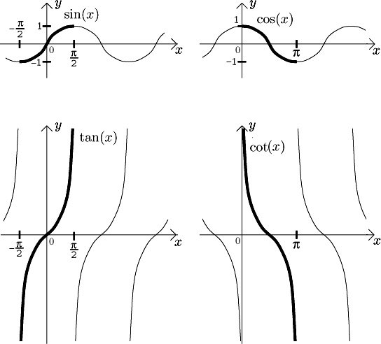

Then we consider inverses to these restrictions. They are called *arc sine* (denoted arcsin), *arc cosine* (denoted arccos), *arc tangent* (denoted arctan) and *arc cotangent* (denoted arccot). The graphs of these functions are here:

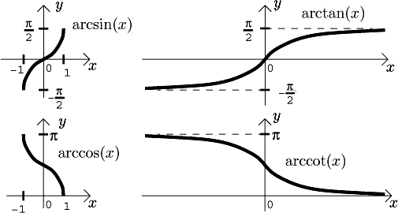

We now list the basic properties of these inverse trig functions. They are all continuous, monotone and bounded.

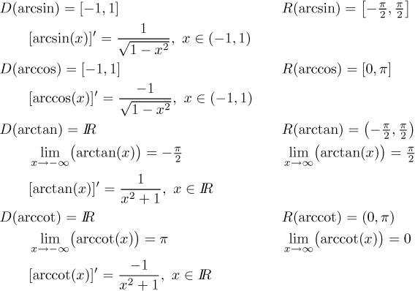

**Note:** Many authors (and most calculator makers) actually use a different notation, namely sin-1(*x*), cos-1(*x*) etc. This notation is extremely misleading and many students indeed see an admittedly strong similarity between sin-1(*x*) and, say, sin2(*x*) for the square of sine; logically they then expect that sin-1(*x*) is actually 1/sin(*x*). Of course, the inverse to sine and 1/sin(*x*) are entirely different functions. Although there is a reasonably good justification for this notation (see our exposition of [inverse functions](http://math.feld.cvut.cz/mt/txtb/3/txe3ba3a.htm) in Theory - Real functions), it is very unfortunate because of these misunderstandings. Since there is a perfectly acceptable alternative that is also widely known, namely those arc things, we will always use them here.

**Remark:** Let us return to the original question: We are given a number *y* and we want to find a number *x* satisfying, say, sin(*x*) = *y*. If this *x* is from the region to which we restricted sine a moment ago, then we have the solution *x* = arcsin( *y*). But what if for some reason we need *x* from a different part of the real line? Or taken from another point of view, if we restrict sine to a different reasonable interval, what would be the formula for the inverse function to such a restricted sine? (And of course also to cosine etc.) The following formulas are true:

* Let sin(*x*) = *y*.   
  If   2*k*http://math.feld.cvut.cz/mt/pics/piccpi.gif - http://math.feld.cvut.cz/mt/pics/piccpi.gif/2 http://math.feld.cvut.cz/mt/pics/piccle.gif *x* http://math.feld.cvut.cz/mt/pics/piccle.gif 2*k*http://math.feld.cvut.cz/mt/pics/piccpi.gif + http://math.feld.cvut.cz/mt/pics/piccpi.gif/2   for some integer *k*, then

*x* = arcsin( *y*) + 2*k*http://math.feld.cvut.cz/mt/pics/piccpi.gif.

If   (2*k* + 1)http://math.feld.cvut.cz/mt/pics/piccpi.gif - http://math.feld.cvut.cz/mt/pics/piccpi.gif/2 http://math.feld.cvut.cz/mt/pics/piccle.gif *x* http://math.feld.cvut.cz/mt/pics/piccle.gif (2*k* + 1)http://math.feld.cvut.cz/mt/pics/piccpi.gif + http://math.feld.cvut.cz/mt/pics/piccpi.gif/2   for some integer *k*, then

*x* = (2*k* + 1)http://math.feld.cvut.cz/mt/pics/piccpi.gif - arcsin( *y*).

* Let cos(*x*) = *y*.   
  If   2*k*http://math.feld.cvut.cz/mt/pics/piccpi.gif http://math.feld.cvut.cz/mt/pics/piccle.gif *x* http://math.feld.cvut.cz/mt/pics/piccle.gif 2*k*http://math.feld.cvut.cz/mt/pics/piccpi.gif + http://math.feld.cvut.cz/mt/pics/piccpi.gif   for some integer *k*, then

*x* = arccos( *y*) + 2*k*http://math.feld.cvut.cz/mt/pics/piccpi.gif.

If   (2*k* + 1)http://math.feld.cvut.cz/mt/pics/piccpi.gif http://math.feld.cvut.cz/mt/pics/piccle.gif *x* http://math.feld.cvut.cz/mt/pics/piccle.gif (2*k* + 1)http://math.feld.cvut.cz/mt/pics/piccpi.gif + http://math.feld.cvut.cz/mt/pics/piccpi.gif   for some integer *k*, then

*x* = (2*k* + 2)http://math.feld.cvut.cz/mt/pics/piccpi.gif - arccos( *y*).

* Let tan(*x*) = *y*.   
  If   *k*http://math.feld.cvut.cz/mt/pics/piccpi.gif - http://math.feld.cvut.cz/mt/pics/piccpi.gif/2 < *x* < *k*http://math.feld.cvut.cz/mt/pics/piccpi.gif + http://math.feld.cvut.cz/mt/pics/piccpi.gif/2   for some integer *k*, then

*x* = arctan( *y*) + *k*http://math.feld.cvut.cz/mt/pics/piccpi.gif.

* Let cotan(*x*) = *y*.   
  If   *k*http://math.feld.cvut.cz/mt/pics/piccpi.gif < *x* < *k*http://math.feld.cvut.cz/mt/pics/piccpi.gif + http://math.feld.cvut.cz/mt/pics/piccpi.gif   for some integer *k*, then

*x* = arccotan( *y*) + *k*http://math.feld.cvut.cz/mt/pics/piccpi.gif.

There are very interesting formulas relating trig functions and their inverses. They are seldom used, but they are so cute we can't resist putting them here.

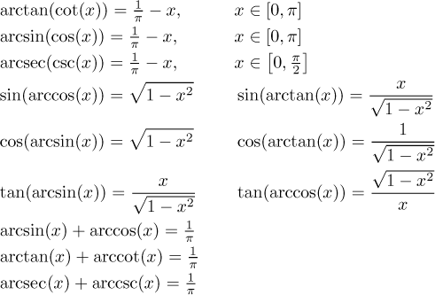

## Secant and cosecant

We will just briefly review their properties. Graphs:

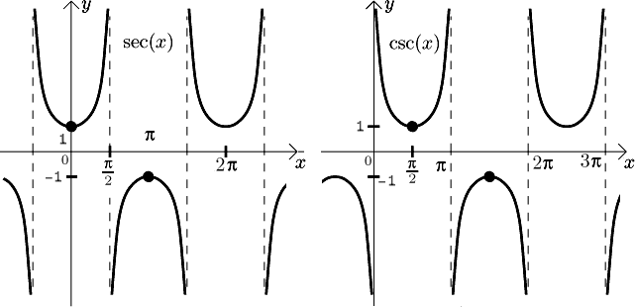

Derivatives:

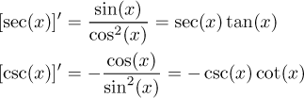

[Hyperbolic functions](http://math.feld.cvut.cz/mt/txtb/4/txe3ba4f.htm)   
[Back to Theory - Elementary functions](http://math.feld.cvut.cz/mt/txtb/4/txe3ba4.htm)

=